To: Randy Larimer
From: Jay Lamb
Regarding: Lab #3, Virtex4 LCD Interface
Date: February 9, 2009

Summary:
The third laboratory assignment uses the Virtex4 FPGA introduced in the previous experiment to create a basic LCD driver. The five GPIO buttons will be used in conjunction with the LCD to create the complete system. The finished system will work by writing the corresponding character, (N,S,E,W,C), to the LCD when its button is pressed. No restrictions have been outlined as to how the characters are to be written to the screen, the goal is to simply map the GPIO buttons to the LCD, and demonstrate that the connection is working correctly.
Objectives:
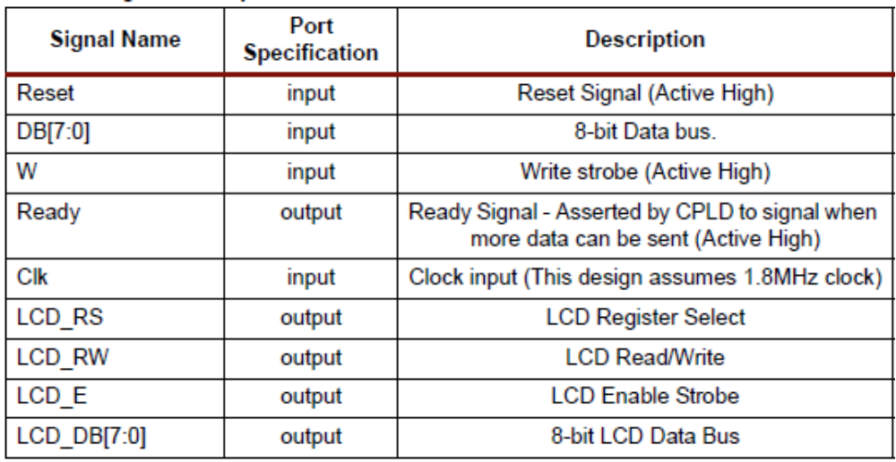
The objective of this experiment is to demonstrate how the different systems on the Virtex4 FPGA evaluation board can be connected. Like the GPIO buttons and LEDs used in the previous experiment, the LCD will have several connections that will need to be mapped to various input/output pins on the FPGA. In order to construct the system, a basic knowledge of the input/output requirements for the LCD will need to be outlined. With the inputs/output requirements known, a top-level diagram of the complete system can be created. With the system drawn up, the only remaining objective will be the creation of a VHDL process that will write the correct character to the screen when the button is pressed.

Methods:
To begin, a layout of the LCD's input/output connections needs to be outlined. The LCD built into the evaluation board has the input/output layout described in figure 1.

Figure 1. Input/output for the eval. Board LCD

Connections required for this experiment will include all of the available inputs, and all of the outputs, except for the LCD_DB bus.
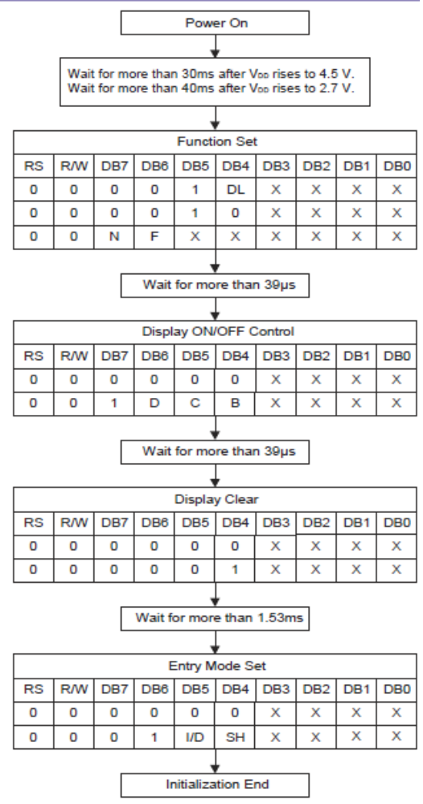
As soon as the simulation begins, the LCD needs to be initialized before it will operate. The LCD on the evaluation board is constructed only for use in 4-bit mode, so the appropriate initialization codes need to be sent to the LCD before it can be used. The 4-bit initialization procedure is outlined in figure 2.

Figure 2. 4-bit initialization prodcedure

Once the LCD has been initialized, it is now possible to write a character to it. This is done by sending the LCD a pair of 4-bit words. Each possible combination of words corresponds to a different character. This is done by setting the EN and RS lines, clearing the RW line, and writing the first nibble to the DB[4:7] bus. Immediately following this step, the second nibble is written to DB[4:7], and is clocked in. Once the two words have been clocked in, the character will appear on the LCD. The system will the enter a wait state. While in this state the system will simply run through a loop, waiting for one of the GPIO buttons to be pressed. The process that writes characters to the LCD is sensitive to changes in the values of the GPIO buttons, so if a button is pressed, the data is changed, and the process is triggered, writing the character to the LCD.

Test:
The easiest and most obvious way to test this system is to see what happens when each of the GPIO buttons is pressed. Pressing any of the five buttons should cause the “write” process to be triggered, causing the corresponding character to appear on the LCD. If the correct value appears for each of the five keys, then the code is assumed to be functioning correctly.

Code(attached):
  - clock_div
  - counter
  - lcd_blkbx
  - lcd_clock_div
  - lcd_counter
  - test_top
  - top

